DHRUV GUPTA

2023EE30858

COL 774

Assignment 2

**1-Naive Bayes**

1.1

(a)

* Train Accuracy – 97.8%
* Test Accuracy – 95.02%

(b) World Cloud for different classes are:-

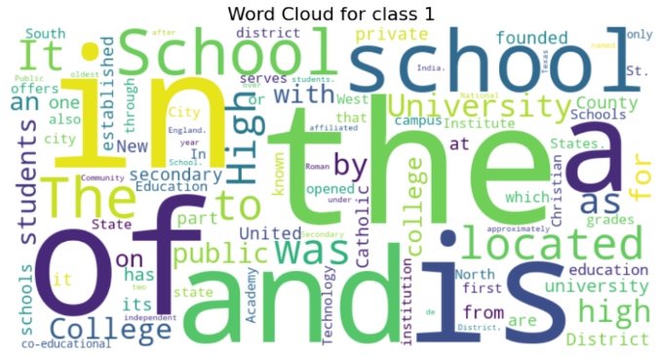

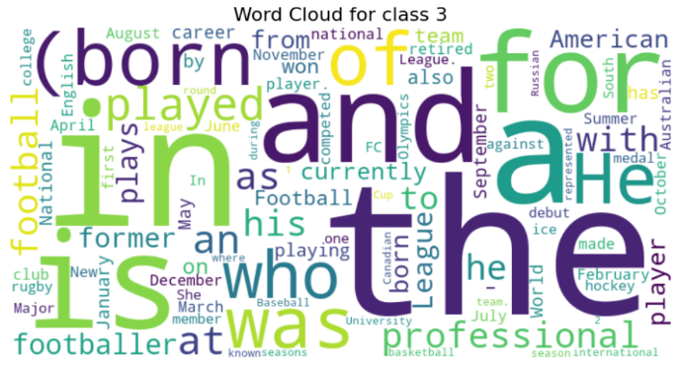







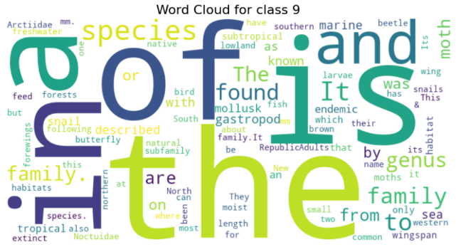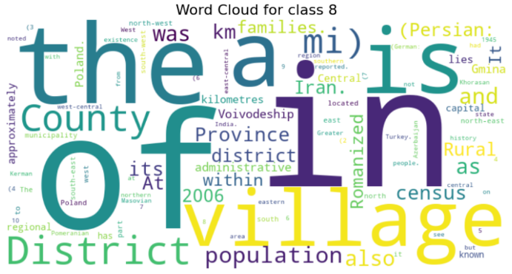



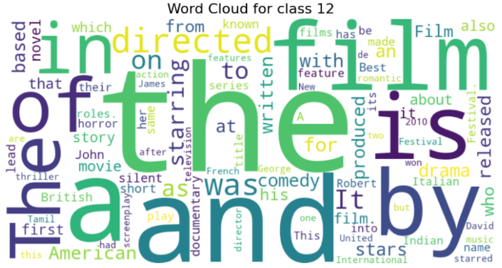

1.2  
(c)

* Train Accuracy – 96.1%
* Test Accuracy -94.29 %

(b)New World Clouds are –

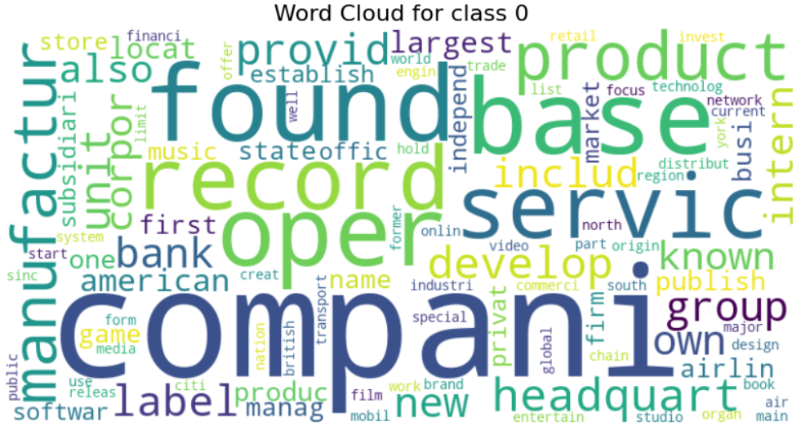

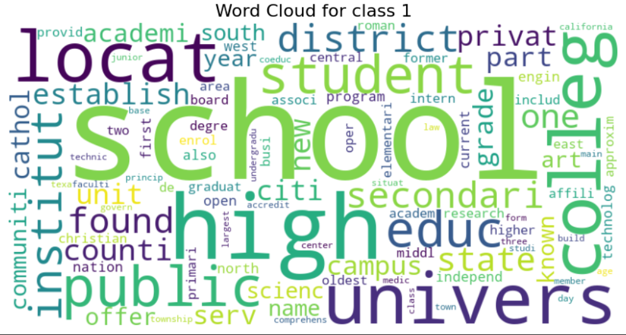



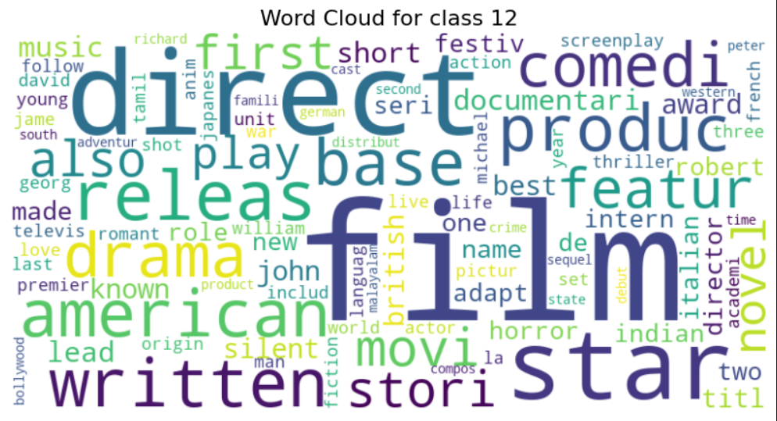





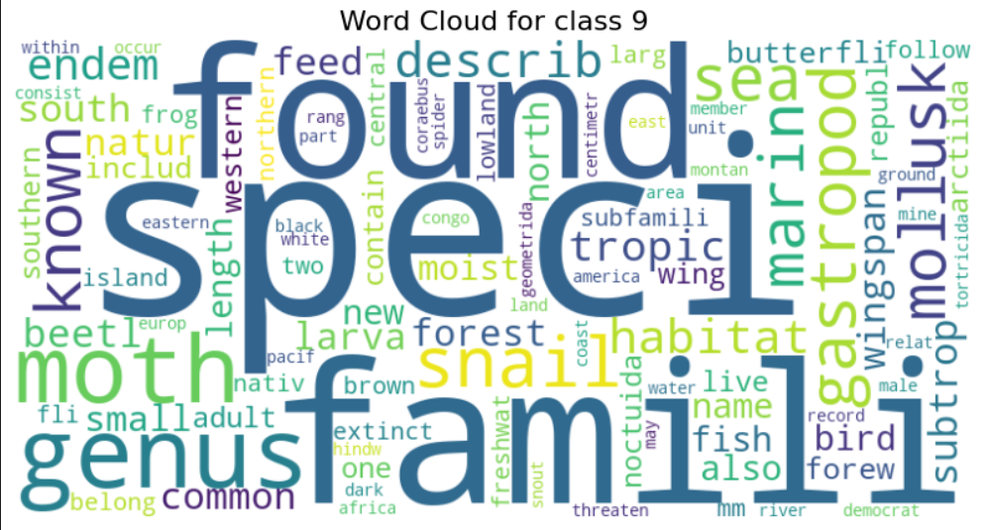

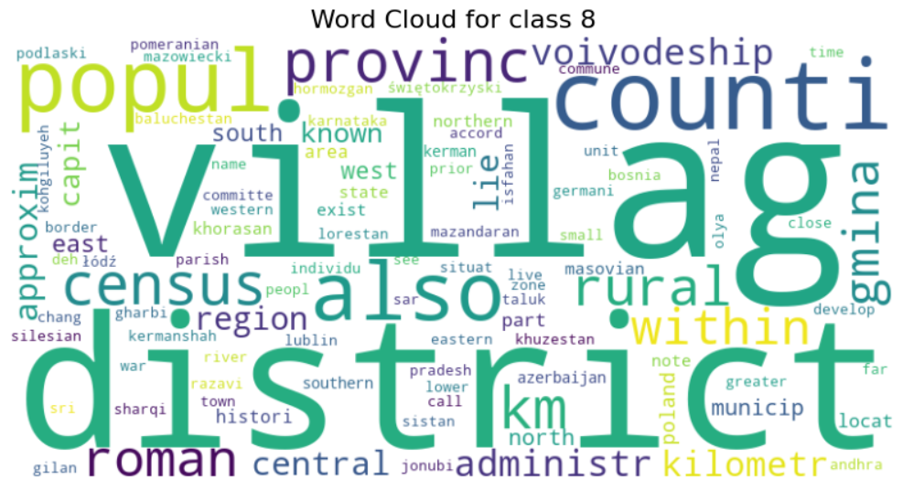

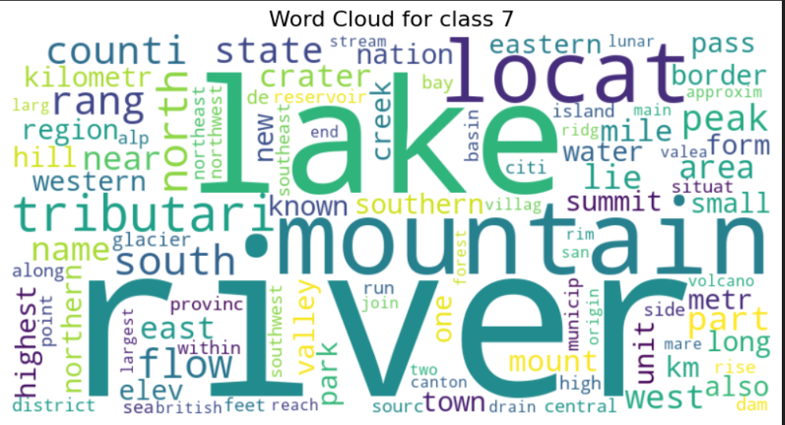







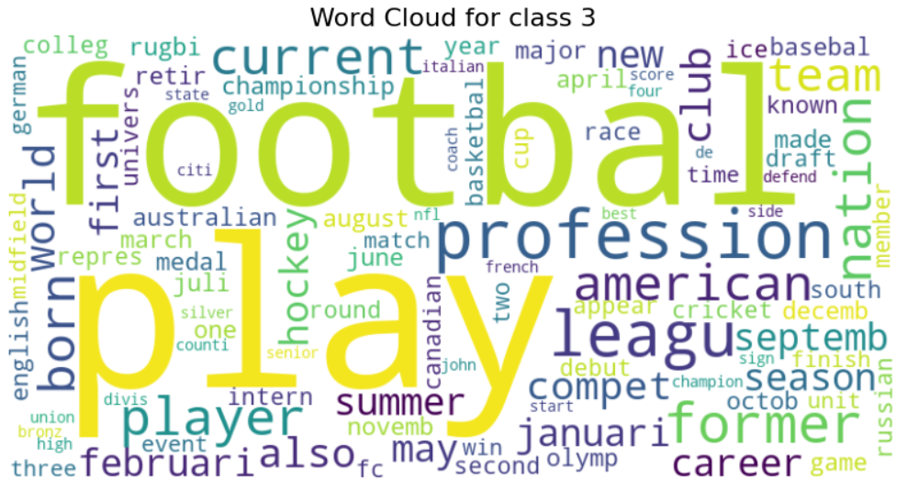



1.2

(d)

Comments on Accuracy – The word clouds show the frequency of the various word stems rather than the frequency of the words themselves. Stemming is a crude morphological process, not linguistic. Example- “policy” -> “polici” , where has no meaning , therefore some word may loose their essence and such tokens are *less interpretable* and *may collide* with unrelated words, leading to feature ambiguity. The model may see fewer unique feature but also lose discriminative ones. Stop word removal may disregard meaningful distinctions like “not good” becomes “good” removing word not changes the meaning. stemming or stopword removal removes too many unique terms, it reduces the feature richness, making class boundaries less separable. The model loosed train data and thus produces less test accuracy as compared to without preprocessing.

1.3

For unigram + Bigram model :-

Test Accuracy – 95.44%

Train Accuracy – 98.92%’

Comments –This gives better accuracy then preprocessing alone because a unigram model considers only single words as features (e.g., “good”, “movie”, “boring”).  
A bigram model considers pairs of consecutive words as additional features (e.g., “not good”, “very boring”, “good movie”). Therefore it contains meaning along with adjective references that describe its contextual meaning. When we combine them (unigram + bigram), our model’s feature space becomes richer and more informative this leads to better accuracy.

1.4

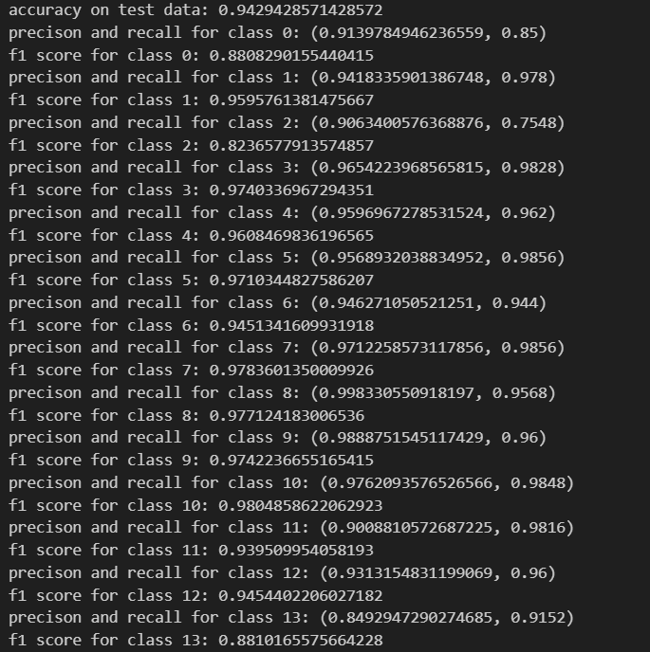# For Preprocessing(stemming+stopword removal ) -

#For unigram+birgram model with preprocessing –

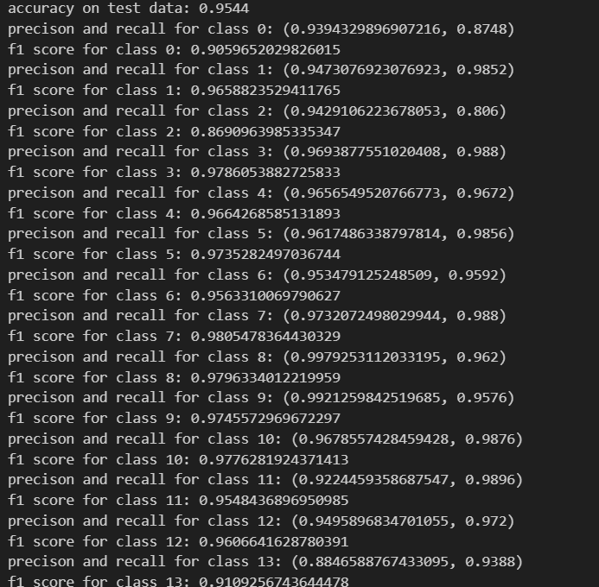

#For Unigram+Bigram without preprocessing

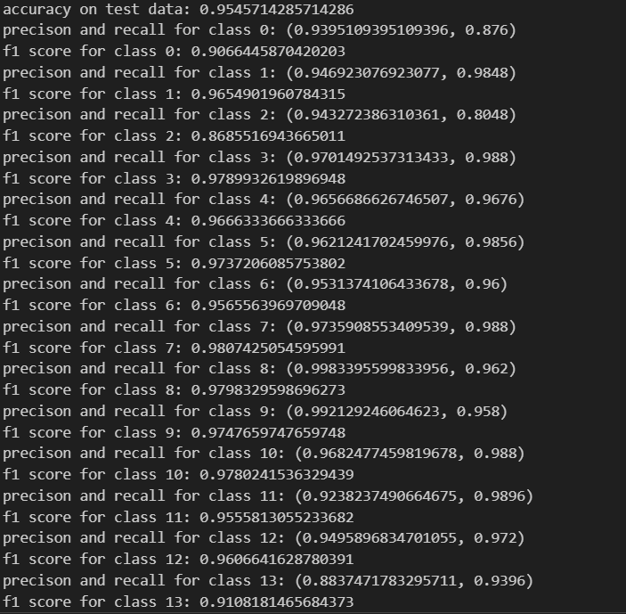

#For Bigram alone –

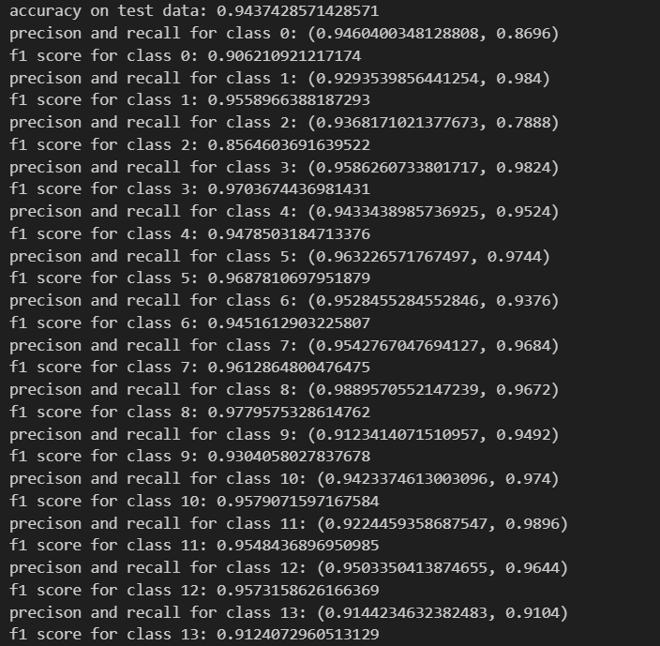

Comments – According to these metrics our best performing model is unigram + bigram without preprocessing, however this model does overfit the training data with 98.8 % train accuracy, but as it process more test accuracy than other , it can be regarded as the best model. The unigram+ bigram model with preprocessing although process same accuracies but because of the reasons describes before I tend to overlook preprocessing model. The F1 score for the selected model are also best when compared to others.

1.6

(a) Concatenating both content and title

Train Accuracy = 99.1 %

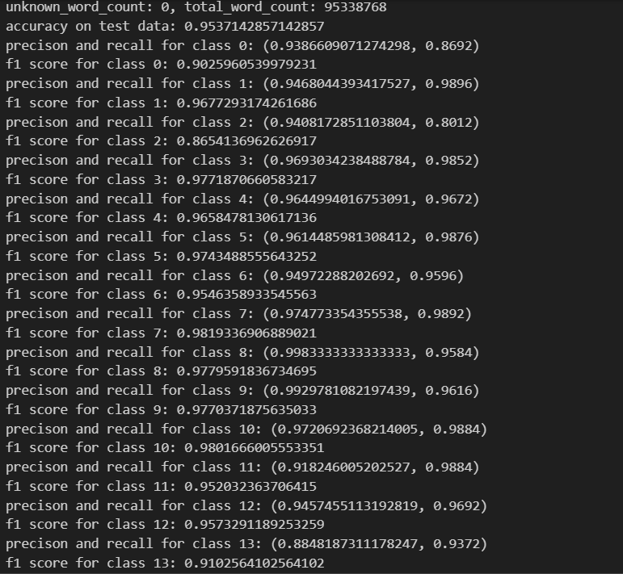

Comments - Accuracy on test as well as train is more compared to our best model with only title or content feature. The reason is that after using both features as a single concatenation we get mode train data and also some unique features and meaning of those features(encoded with the help of bigram) , this help train the model to be more sophisticated , leading to better accuracies.

1.6

(b) Treating content and title independently , Train Accuracy = 99.145%

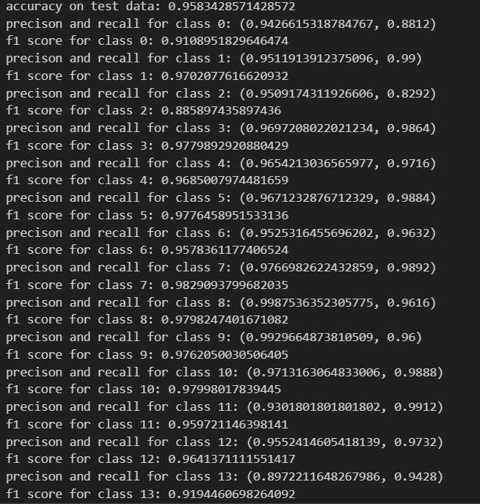

Comments -**:**

The model in part (b) achieves higher accuracy because it learns separate parameters for the title and content, allowing each to capture its own distinct word distributions and predictive patterns. Titles are typically short and keyword-rich, while content is longer and more contextual, so forcing a single shared parameter set (as in part a) makes the model compromise between two different linguistic styles. By estimating separate parameters, the model can weigh each source appropriately, preserve the strong discriminative signals from titles without dilution, and fit the overall likelihood more effectively. This flexibility leads to better modeling of both sources of information and, consequently, improved classification performance.

1.5

#using only unigrams without any preprocessing

Accuracy on train data = 90.52%

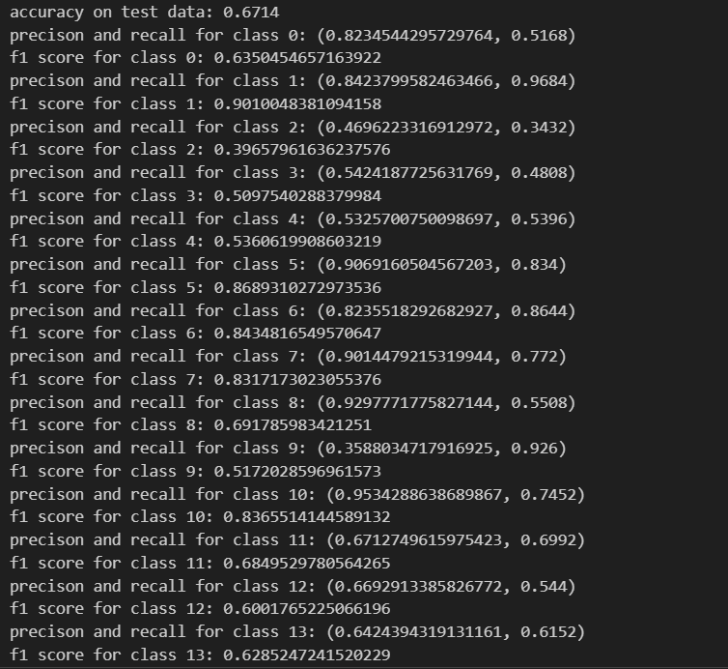

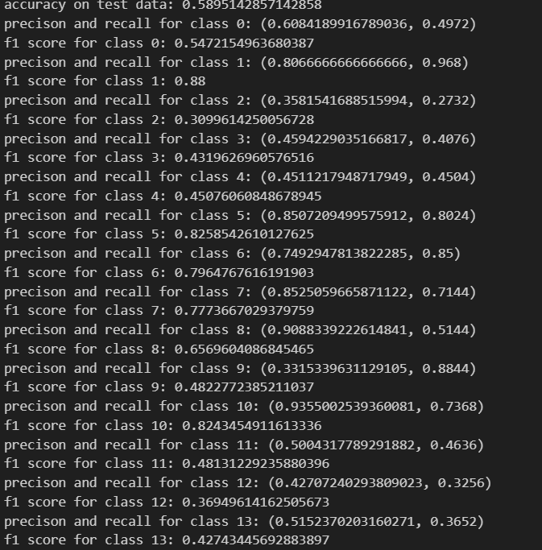#using only preprocessing , train accuracy = 82.6%

#using unigram+bigram+preprocessing , Train Accuracy – 90.6%

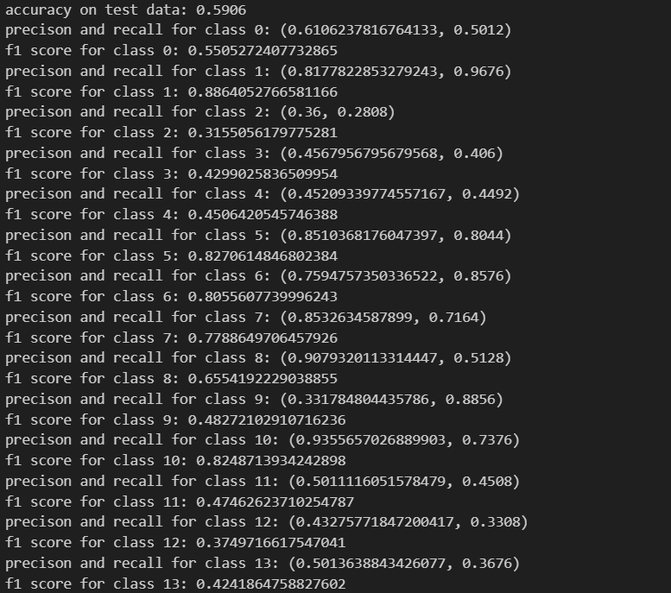

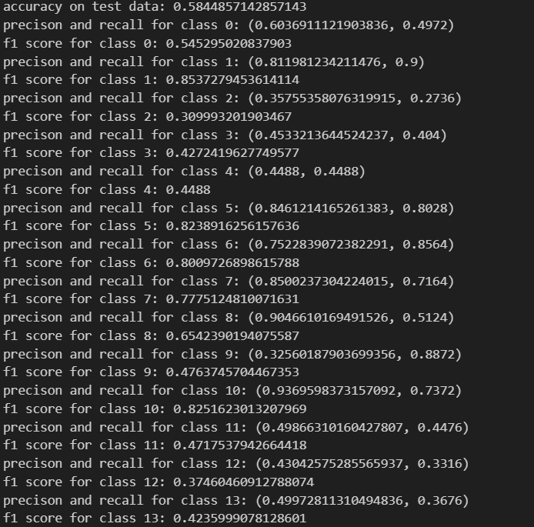#for unigram + bigram without preprocessing , train accuracy = 90.64%

Comments – Here the test accuracy are very low compared to the model where we use content feature, this is because the availability of content feature data is significantly more when compared to the title feature model. More data means more better training and more better model predictions.

1.7

(a) Predicting each class randomly for every test data gives test accuracy as 70.03%

(b) Predicting any random class as positive for whole test data gives accuracy as 71.42%

(c) My Algorithm gives 25.8 % improvement over the baseline prediction from (a) and 24.41% improvement over baseline prediction from (b).

1.8 Confusion matrix

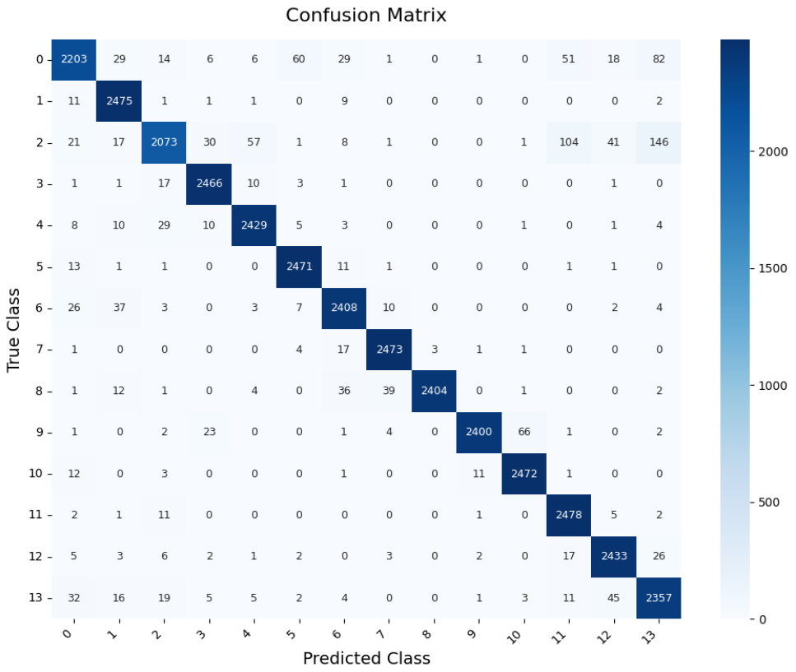Our best performing class on test data is when we treat title and content independently and apply unigram + bigram model without preprocessing involving stemming and stop word removal.

(a)

Class 11 has the maximum diagonal entry , this means that maximum correct predictions are for class 11 , implying that model can best classify class 11 among other classes

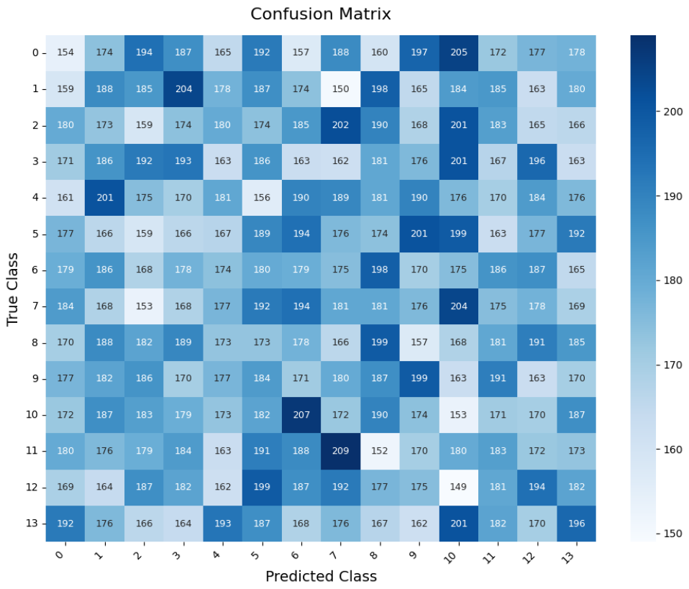(b)For Randomly predicting each test data (1.7a)

Class 8 & 9 has the maximum diagonal entry , this means that maximum correct predictions are for class 8&9 , implying that model can best classify class 8 & 9 among other classes

For Randomly predicting one class as positive for whole test data (1.7b)

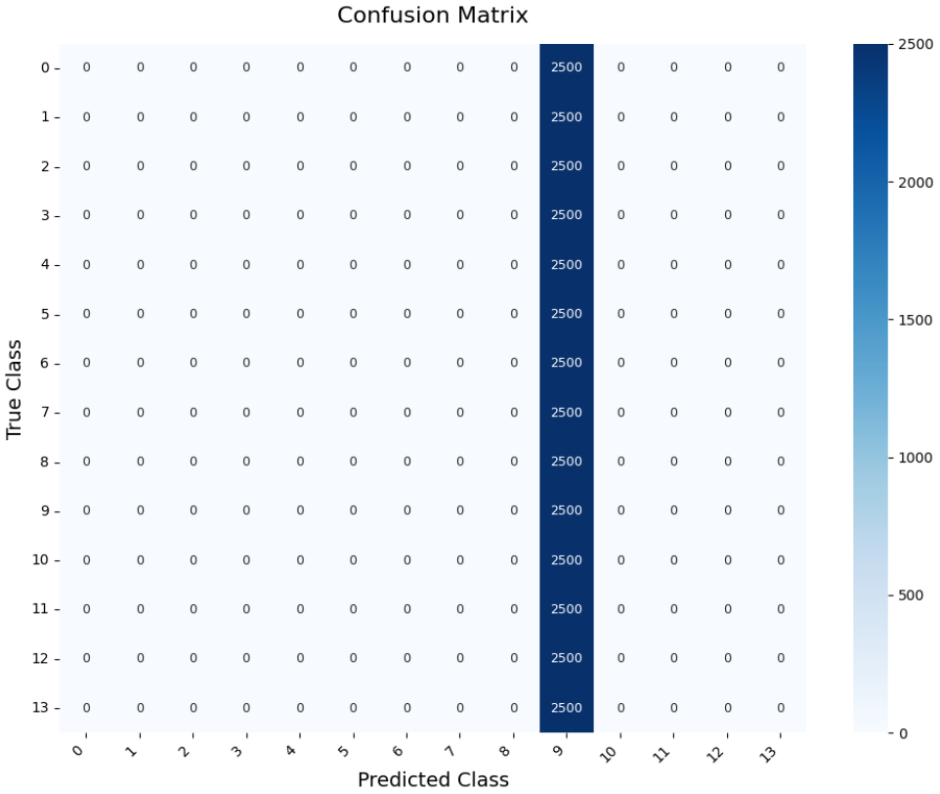

Class 9 has the maximum diagonal entry , this means that maximum correct predictions are for class 9 , implying that model can best classify class 9 among other classes. Therefore, the random positive classes chosen was class 9 for all the test data.

1.9

For Unigram + Trigram , Train Accuracy = 99.50%

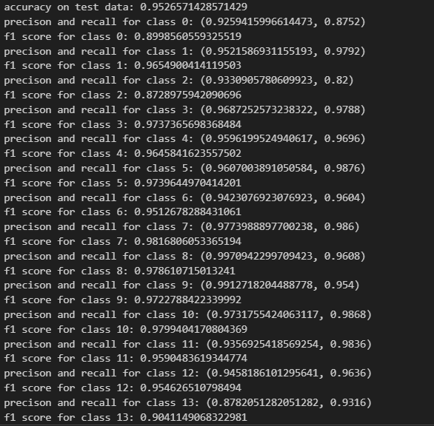

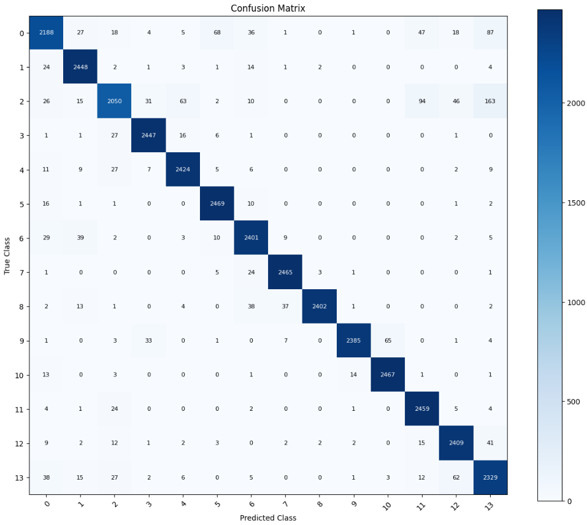Confusion Matrix

Comments – This model gives best train accuracy as 99.5 % but a smaller test accuracy as compared to our previous best model. Indicating that trigram feature inclusion overfits the data to training data provided and hallucinates when encountering new test data , thereby giving less test accuracy.

Including trigrams instead of bigrams increases the model’s feature space and captures more specific, longer word sequences, which often leads to better memorization of the training data but poorer generalization to unseen data. Trigrams tend to be much sparser many of them appear rarely or only once so while they help the model fit nuanced patterns in the training set, they also make it more prone to overfitting. In contrast, bigrams strike a better balance: they capture useful local context (“not good”, “very happy”) without fragmenting the data too much. Thus, our higher training accuracy with slightly lower test accuracy indicates that the trigram model has learned overly specific patterns that don’t generalize well beyond the training examples.

2 – SVM

2.1

(a) Number of Support Vectors: 1286 ,for αi >= 10−5, Percentage of Support Vectors: 38.57%

(b) Using b = - (np.max(wTx_neg) + np.min(wTx_pos)) / 2 we get test accuracy as 78.97 % and train accuracy as 93.73 %

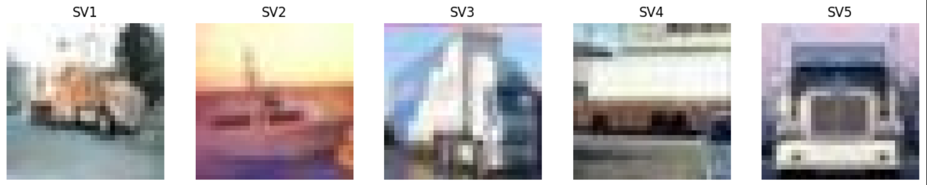(c) Top 5 coefficients in image form are

And the image corresponding to w vector is

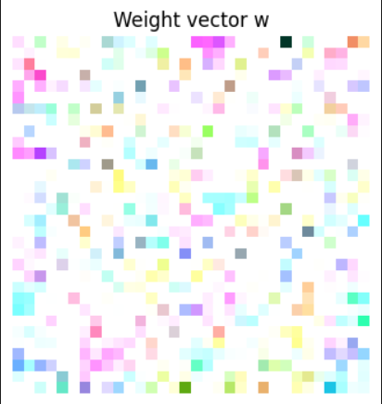

2.2

(a) number of support vectors: 1811, for αi >= 10−5 , percentage of support vectors: 54.31913617276545%

Number of matching support vectors: 1058

percentage of matching support vectors: 82.27060653188181 %

(b) Test accuracy = 85.735 %

(c) Top 5 images are

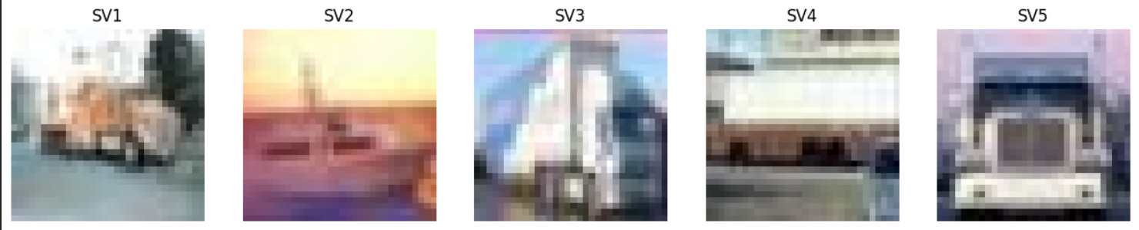

(d) Comments – A slight increase in Test accuracy is observed.

2.3

(a) Number of support vectors by LIBSVM (linear kernel): 1281 , Number of support vectors by LIBSVM (Gaussian kernel): 1793 . Matching SVs (linear): 1281/1286 (99.61119751166407%) Matching SVs (Gaussian): 1793/1811 (99.00607399226946%)

(b)Comparison With Sklearn , The weights are well within 10−2 error range.

b for sklearn linear svm is -2.054585483154745

b for cvxopt linear svm is -2.290540054964408

w-image for cvxopt linear is w-image for sklearn linear is

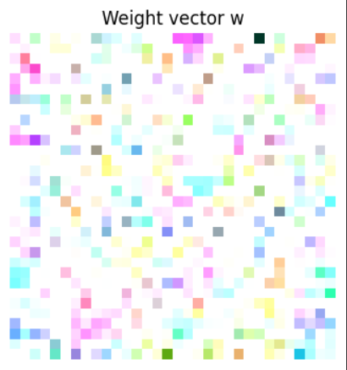

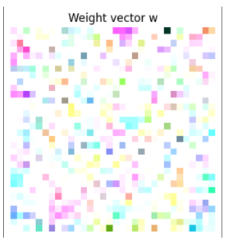

(c) Accuracy for sklearn linear svm is 79.12912912912913 ,Accuracy for sklearn gaussian svm is 86.1861%, There is no large variation in accuracy with Sklearn as compared to cvxopt, for sklearn accuracies are slightly more.

(d) Time taken by LIBSVM for linear kernel: 26.406556606292725

Time taken by LIBSVM for Gaussian kernel: 18.278961181640625

Time for CVXOPT –

Linear –

Gaussian –

The training time was slightly less for sci-kit learn implementation than

CVXOPT implementation for both linear and Gaussian kernels.

2.5

(a) Test accuracy for multiclass image classification with One-vs-One SVM with Gaussian kernel – 43.72372372372372%, Training Time is approximately 35 minutes.

2.6

(a) Time taken to train multi-class SVM using sklearn: 769.7957701683044 seconds

Final accuracy using sklearn SVM with Gaussian kernel: 43.66366366366366%

(b) Comments – The accuracies for both model are same , with one v/s one model outperforming sklearn by approximately 0.06 %. Sklearn models take significantly less time to train.

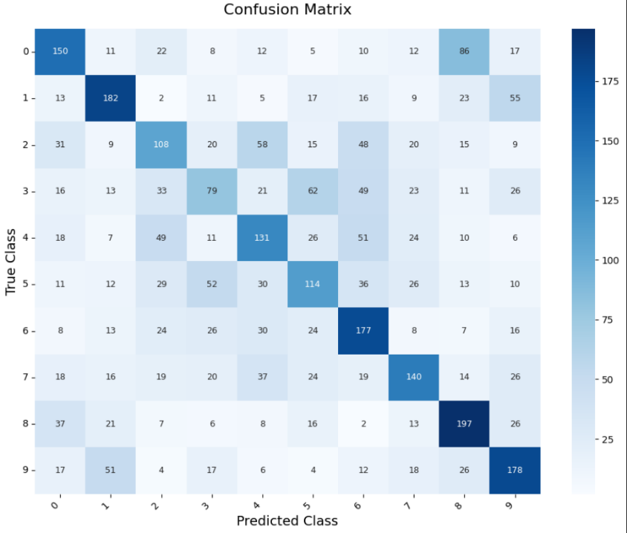2.7

(a) Confusion Matrix for CVXOPT predictions.

Confusion Matrix for Sklearn - LIBSVM.

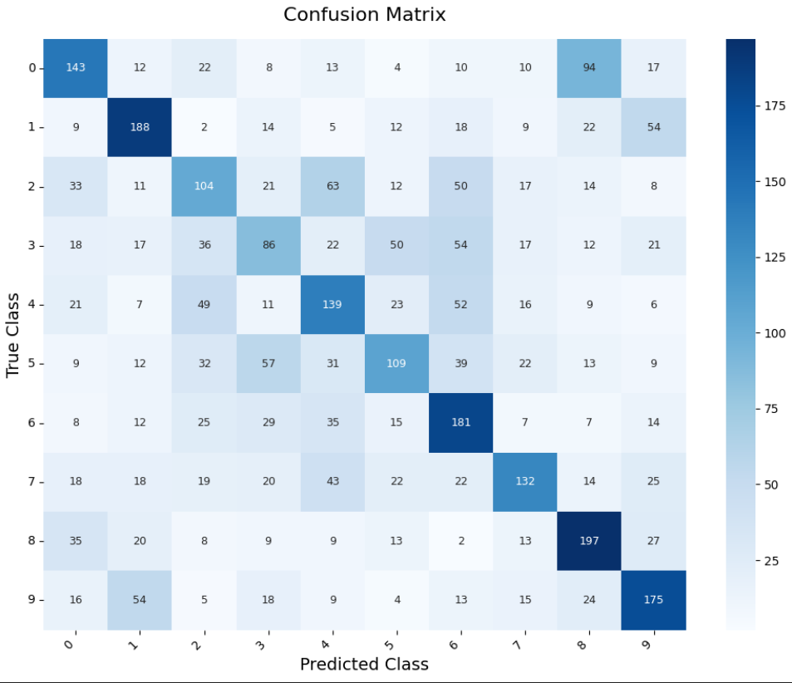

Most Misclassified class is CAT

Comments - We can see the due to large regions of same colors, the background and foreground blend into one another and makes it harder to predict the class of these images. Even visually, we can hardly make out the difference in the images.

2.8

(a) We see an increasing trend, where the best accuracy is given by the hardest classifier i.e. for C = 10. This value also gives the best test set accuracy. The value of C tells the classifier how much we want to avoid misclassifying each example: larger values of C will mean less misclassifications on the training dataset, but this may lead to overfitting. In our case, for small values of C, the model underfits, and chooses a very broad decision boundary, leading to poor cross-validation/test accuracy.